

**Mobile Application Development (MAD2101MA)**

**MAD400-75 iOS Development**

**(Assignment 1)**

**(Part 2)**

**Submitted to:**

**Prof. Manhar Kapoor**

**Submitted by:**

**Gurpreet Kaur**

**Student ID: A00117508**

**Date: 17-07-21**

**INDEX**

|  |  |  |
| --- | --- | --- |
| Topic No. | Topic Name | Page No. |
| 1 | Introduction of Xcode | 3-4 |
| 2 | Capabilities of xcode | 4-5 |
| 3 | Interface Builder | 6 |
| 4 | How to download and install XCode on mac | 6-9 |
| 5 | How to download and install XCode on window | 9-10 |
| 6 | Conclusion | 11 |
|  | References | 11 |

**1. Introduction of XCode**

XCode is introduced by Apple in 2003. It is an IDE (Integrated Development Environment) which contains software packages. There are different types of software tools are available which helps to create software for OSX and IOS. It is freely available on Mac app store. It is also possible to download XCode on windows with some completions.



The developers who are already register, they are able to download the previous versions of xcode and also preview the releases with the help of apple developer website. Tools like editors, compilers and many other which are required for the successful development, they all are included in xcode. Xcode is basically used for the development of apple’s products like iPhone, iPad and Mac. IDE of project builder was rewritten that was called PBX for a while. The Xcode is mainly created for the development of single window interface. It supports version control through GIT or Subversion. The environment of developing code with Xcode is very rich and powerful. Software is able to run on PowerPC and Intel-based platforms through universal binaries. The universal binaries can be created by Xcode.

**2. Capabilities of XCode**

There are different types of capabilities in xcode which we can add in our app. These are mentioned through built points: -

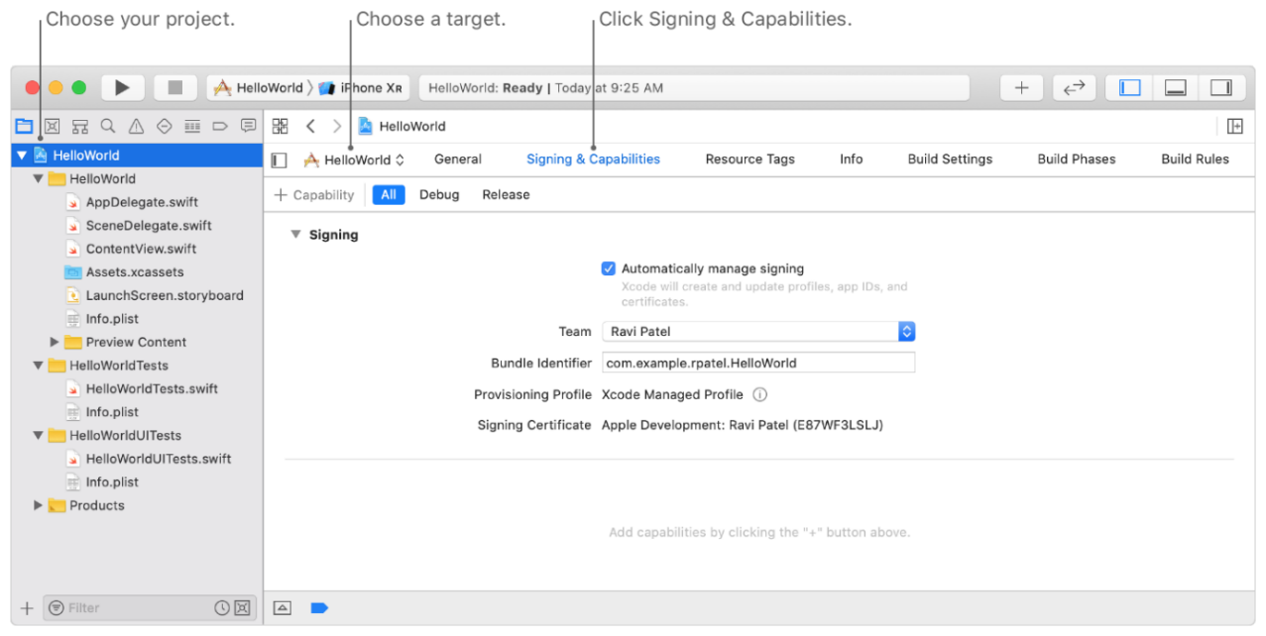

* Through signing and capabilities pane, we can add capabilities in our app. That pane is available in the project editor on main window.
* We can also select project from project navigator.
* In the project editor, there is one option to select the target through which we can choose our app’s target.

After choosing the target, click on signing and capabilities tab. It shows one option that is select a build configuration. It helps to add the configurations.

For example: - suppose you want to add only one configuration like debug so you select Debug otherwise click on All.

* By clicking on the library button, Capabilities library can be opened.
* We can also add the app target capabilities like create an app group and select an app group.

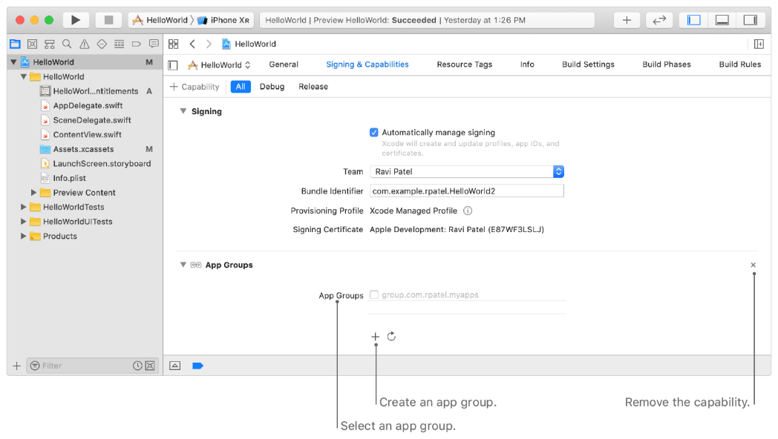

**3. Interface builder**

There is no need to write a code, when we create user interface with Interface builder editor. We can add buttons, text fields and many other functions in our user interface by simply using drag and drop.

We can develop cocoa touch with the help of Model-View-Controller pattern. It helps to separate the implementations of the interface and we can make interface independently. User interface mainly supports the object like cocoa touch. When the application is in its running process then the connection between UI and code is built by macOS and iOS.

**4. How to download XCode on mac**

There are two different ways to download XCode on mac One is from app store and another is from apple developer’s side.

**Download XCode from app store**

* Firstly, go to the app store. Here you have a need to create apple id if you don’t have it before.
* Search XCode in the search box. Then XCode window will appear.
* On the top right corner of the XCode window, there is get option. Click on it. Then the downloading will be start.

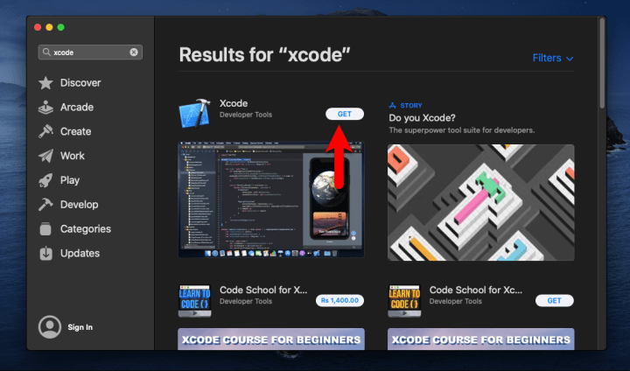

But in this method, there is some troubles like the downloading will be stuck after the half completion. So, sometime, users have to face some problems while downloading the mac from app store.

**Download XCode through apple developer’s site**

* Initially to go this link: <https://developer.apple.com/download/more/>
* After that sign in page will open. You can sign in with your previous id or you also create new one.
* Then one page will open and all the versions of XCode are available on that particular page.
* Click on one of them. Then download option will appear. The downloading will start after clicking on the download option.
* The zip folder will be downloaded.

**Install XCode on mac**

* Go to the download.
* Find the downloaded folder and double click on it. It will be verifying the downloading. It will expand the zip and download.
* In this way, XCode will be installed.

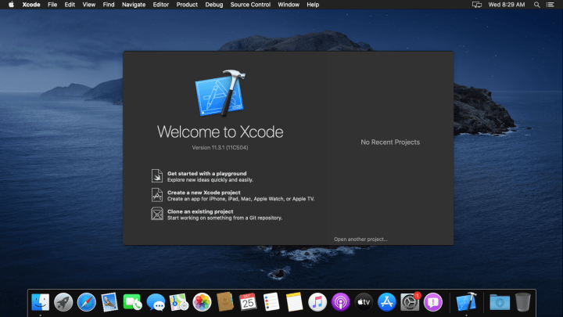

**5. How to Download and install XCode on windows**

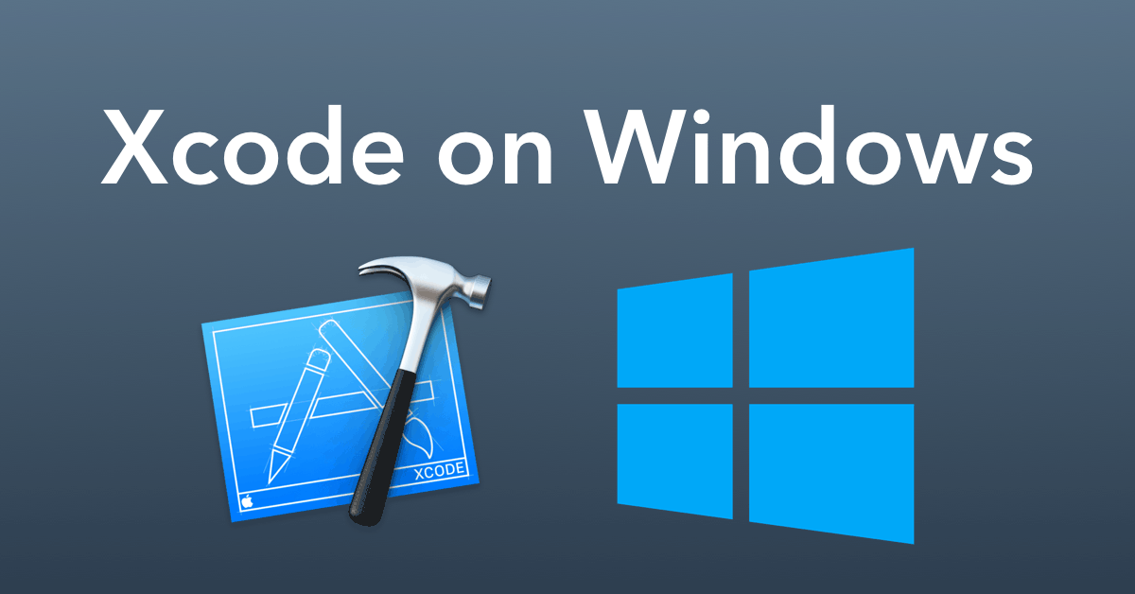

* Go to app store.
* It will be asking about your apple id. Sign in with your apple id.
* In the search box, you will search for XCode. XCode screen will display.
* Click on the get option from XCode screen.
* Then the downloading will start.

**Install XCode on mac**

* Firstly, we have to download virtual box to run XCode on window.
* Then download macOS.
* After downloading the macOS, open virtual box and run it as administrator.
* Crate a machine and put macOS into it.
* Then click on start button.
* The XCode screen will appear.

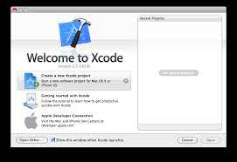

**Conclusion**: - It is very popular for creating an application. There are many ways to learn XCode. But this guide will help people to learn XCode in a simple way.

**References**: -

<https://www.youtube.com/watch?v=NerX55qPiz8>

<https://developer.apple.com/documentation/xcode/adding-capabilities-to-your-app>

<https://www.youtube.com/watch?v=114eUq7-B20&t=3s>